**DIGITAL MARKETING ASSIGNMENTS**

* SARAN.S

**LINKED IN PROFILE**

Profile link -https://www.linkedin.com/in/saran-saran-b31b8b264

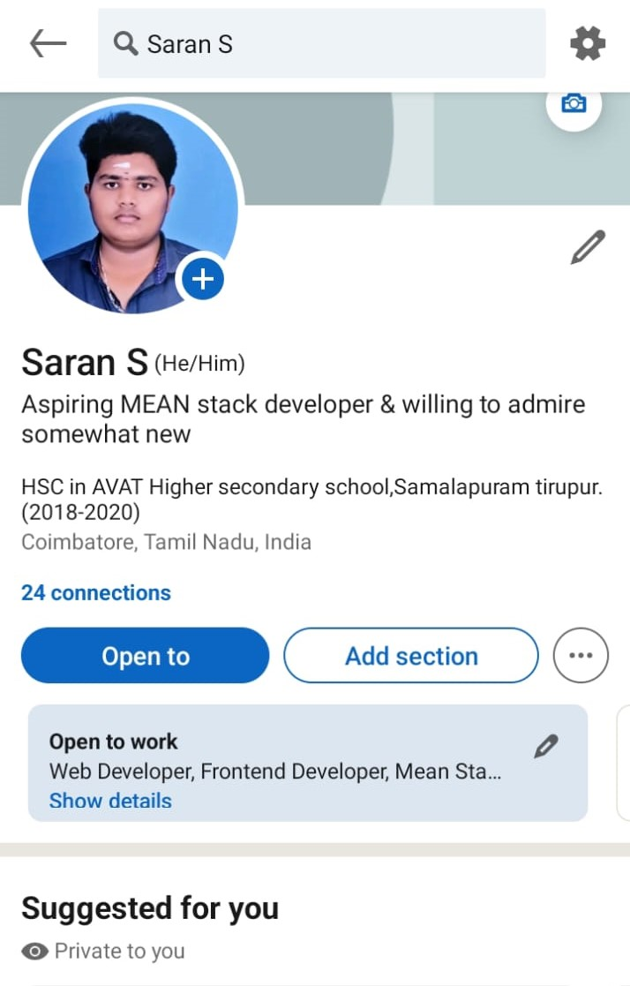

**FACEBOOK PAGE AND THEIR POSTS**

Fb page link- https://www.facebook.com/Medronics

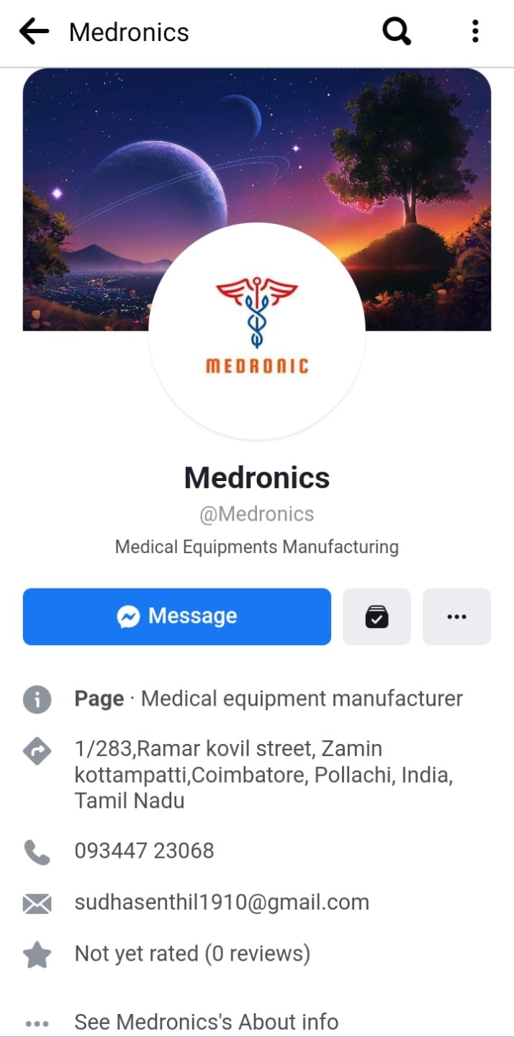

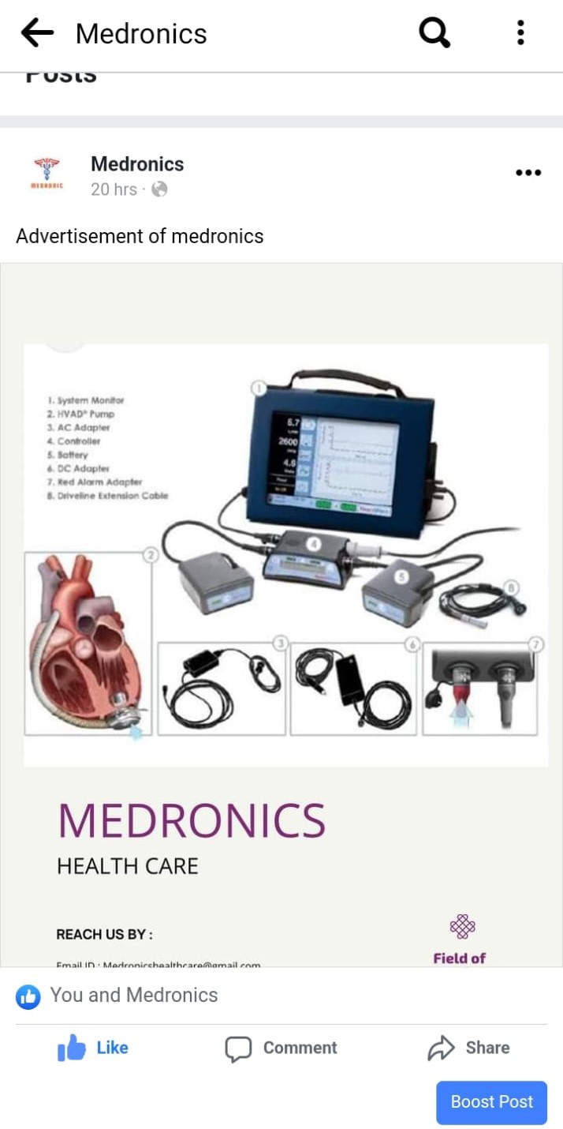

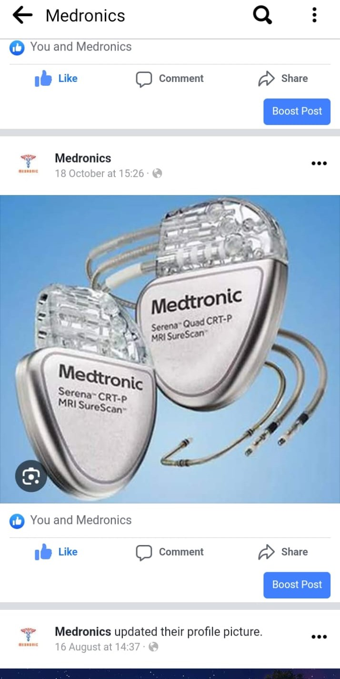

**BLOG NAME – MEDRONICS**

Blog link-medronics2.wordpress.com





**EMAIL NEWSLETTER**

EMAIL NEWSLETTER LINK-https://medronics2.wordpress.com/2023/10/11/email-newsletter/

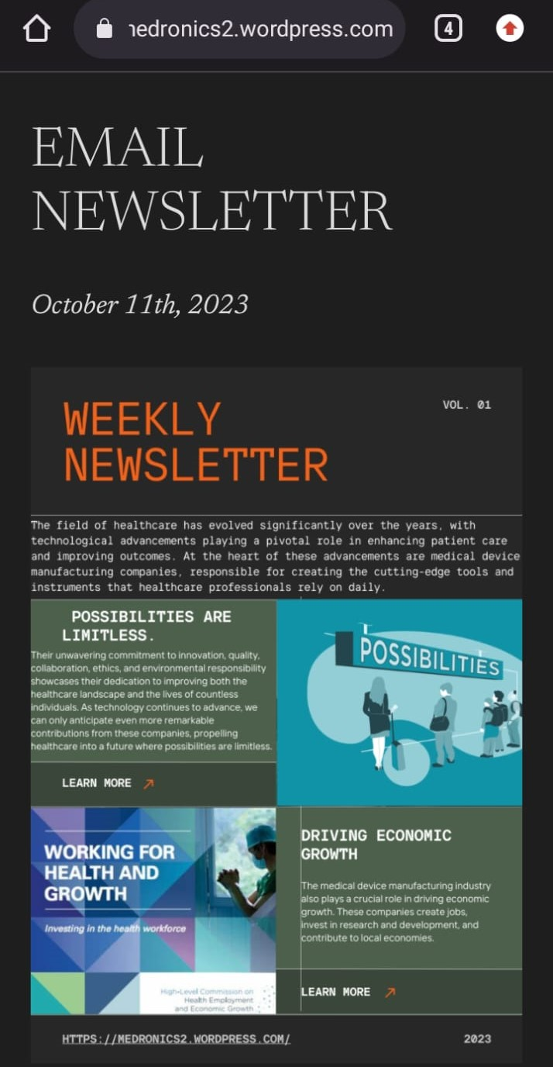

**INFOGRAPHICS**

INGOGRAPHICS LINK - https://medronics2.wordpress.com/2023/10/11/infographic/

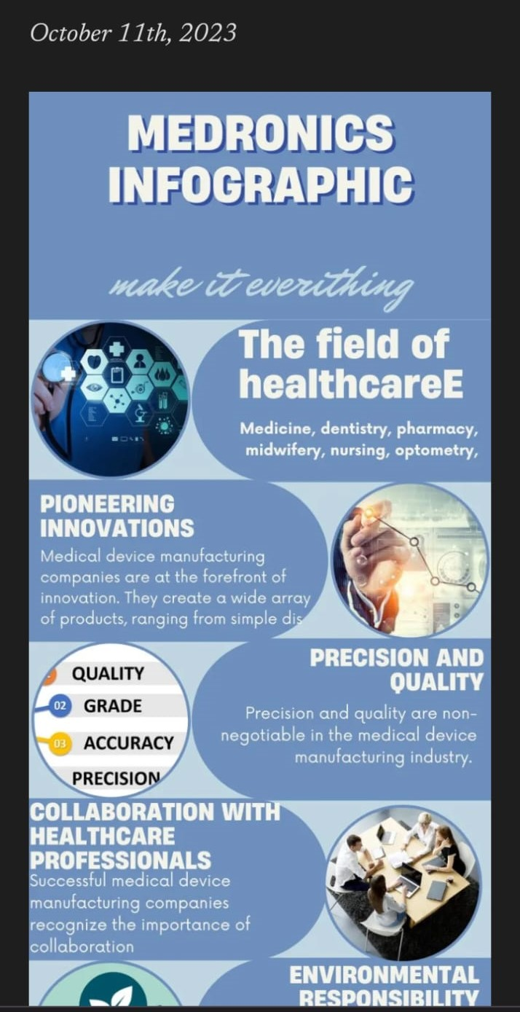

**GOOGLE ANALYTICS AND ITS MEASUREMENT ID**

MEASUREMENT ID - G-69922RY9YN

